ASSIGNMENT - IV
SubTask 1 :- Armstrong Number
Code :-
import java.awt.EventQueue;

import javax.swing.JFrame;
import javax.swing.JPanel;
import javax.swing.border.EmptyBorder;
import java.awt.Color;
import javax.swing.JLabel;
import java.awt.Font;
import javax.swing.JTextField;
import javax.swing.JButton;
import javax.swing.JTextArea;
import java.awt.event.ActionListener;
import java.awt.event.ActionEvent;

public class ArmstrongNumber extends JFrame {
private static final long serialVersionUID = 1L;
private JPanel contentPane;
private JTextField data;
private JTextArea result;
/**
* Launch the application.
*/
public static void main(String[] args) {
EventQueue.invokeLater(new Runnable() {
public void run() {
try {
ArmstrongNumber frame = new ArmstrongNumber();
frame.setVisible(true);
} catch (Exception e) {
e.printStackTrace();
}
}
});
}
/**
* Create the frame.
*/
public ArmstrongNumber() {
setDefaultCloseOperation(JFrame.EXIT_ON_CLOSE);
setBounds(100, 100, 1001, 598);
contentPane = new JPanel();
contentPane.setBackground(Color.PINK);
contentPane.setBorder(new EmptyBorder(5, 5, 5, 5));
setContentPane(contentPane);
contentPane.setLayout(null);

JLabel lblNewLabel = new JLabel("Check Armstrong Number");
lblNewLabel.setForeground(new Color(0, 51, 102));
lblNewLabel.setFont(new Font("Times New Roman", Font.BOLD, 25));
lblNewLabel.setBounds(335, 20, 298, 30);
contentPane.add(lblNewLabel);

JLabel lblNewLabel_1 = new JLabel("Enter a Number :");
lblNewLabel_1.setForeground(new Color(102, 0, 102));
lblNewLabel_1.setFont(new Font("Times New Roman", Font.BOLD, 23));
lblNewLabel_1.setBounds(296, 92, 184, 30);
contentPane.add(lblNewLabel_1);

data = new JTextField();
data.setFont(new Font("Times New Roman", Font.BOLD, 23));
data.setBounds(490, 95, 158, 26);
contentPane.add(data);
data.setColumns(10);

JButton btnNewButton = new JButton("CHECK");
btnNewButton.addActionListener(new ActionListener() {
public void actionPerformed(ActionEvent e) {
String input = data.getText().trim();
int number = Integer.parseInt(input);
int enteredNumber = number;
int digits = input.length();
int sum = 0;
int temp = enteredNumber;
while (number > 0) {
int digit = number % 10;
int power = 1;
for (int i = 1; i <= digits; i++) {
power *= digit;
}
sum += power;
number /= 10;
}
String message;
if (sum == enteredNumber) {
message = "You Entered " + enteredNumber + " with " + digits + " digits, sum of digits^"
+ digits + " is " + sum + ", so it is Armstrong Number.";
} else {
message = "You Entered " + enteredNumber + " with " + digits + " digits, sum of digits^"
+ digits + " is " + sum + ", so it is not an Armstrong Number.";
}
result.setText(message);
}
});

btnNewButton.setBackground(new Color(204, 153, 255));
btnNewButton.setFont(new Font("Times New Roman", Font.BOLD, 18));
btnNewButton.setBounds(418, 182, 117, 33);
contentPane.add(btnNewButton);

JLabel lblNewLabel_2 = new JLabel("Result :");
lblNewLabel_2.setForeground(new Color(51, 0, 204));
lblNewLabel_2.setFont(new Font("Times New Roman", Font.BOLD, 21));
lblNewLabel_2.setBounds(296, 271, 76, 26);
contentPane.add(lblNewLabel_2);

result = new JTextArea();
result.setBackground(new Color(204, 255, 255));
result.setFont(new Font("Times New Roman", Font.BOLD, 23));
result.setBounds(296, 307, 374, 108);
result.setLineWrap(true);
result.setWrapStyleWord(true);
contentPane.add(result);
}
}
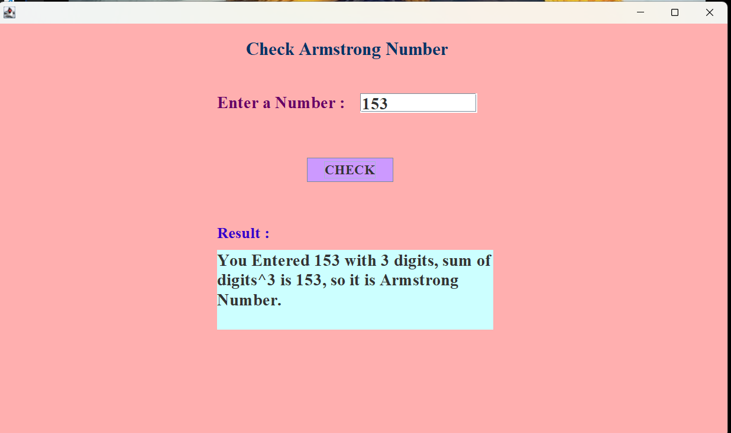
Output :-

SubTask 2 :- Harshad Number
Code :-
import java.awt.EventQueue;

import javax.swing.JFrame;
import javax.swing.JPanel;
import javax.swing.border.EmptyBorder;
import java.awt.Color;
import javax.swing.JLabel;
import java.awt.Font;
import javax.swing.JTextField;
import javax.swing.JButton;
import javax.swing.JTextArea;
import java.awt.event.ActionListener;
import java.awt.event.ActionEvent;

public class HarshadNumber extends JFrame {
private static final long serialVersionUID = 1L;
private JPanel contentPane;
private JTextField data;
private final JTextArea result = new JTextArea();
/**
* Launch the application.
*/
public static void main(String[] args) {
EventQueue.invokeLater(new Runnable() {
public void run() {
try {
HarshadNumber frame = new HarshadNumber();
frame.setVisible(true);
} catch (Exception e) {
e.printStackTrace();
}
}
});
}
/**
* Create the frame.
*/
public HarshadNumber() {
setDefaultCloseOperation(JFrame.EXIT_ON_CLOSE);
setBounds(100, 100, 999, 587);
contentPane = new JPanel();
contentPane.setBackground(new Color(51, 255, 255));
contentPane.setBorder(new EmptyBorder(5, 5, 5, 5));
setContentPane(contentPane);
contentPane.setLayout(null);

JLabel lblNewLabel = new JLabel("Check Harshad Number");
lblNewLabel.setForeground(new Color(153, 0, 153));
lblNewLabel.setFont(new Font("Times New Roman", Font.BOLD, 25));
lblNewLabel.setBounds(335, 20, 298, 30);
contentPane.add(lblNewLabel);

JLabel lblNewLabel_1 = new JLabel("Enter a Number :");
lblNewLabel_1.setForeground(new Color(255, 0, 0));
lblNewLabel_1.setFont(new Font("Times New Roman", Font.BOLD, 23));
lblNewLabel_1.setBounds(296, 92, 184, 30);
contentPane.add(lblNewLabel_1);

data = new JTextField();
data.setFont(new Font("Times New Roman", Font.BOLD, 18));
data.setBounds(490, 95, 158, 26);
contentPane.add(data);
data.setColumns(10);

JButton btnNewButton = new JButton("CHECK");
btnNewButton.addActionListener(new ActionListener() {
public void actionPerformed(ActionEvent e) {
String input = data.getText().trim();
int number = Integer.parseInt(input);
int originalNumber = number;
int sumOfDigits = 0;
while (number > 0) {
sumOfDigits += number % 10;
number /= 10;
}
if (originalNumber % sumOfDigits == 0) {
result.setText("You Entered " + originalNumber +", sum of digits is " + sumOfDigits + ", so it is Harshad Number.");
} else {
result.setText("You Entered " + originalNumber + ", sum of digits is " + sumOfDigits + ", so it is Harshad Number.");
}
}
});
btnNewButton.setBackground(new Color(102, 255, 51));
btnNewButton.setFont(new Font("Times New Roman", Font.BOLD, 21));
btnNewButton.setBounds(418, 182, 117, 33);
contentPane.add(btnNewButton);
JLabel lblNewLabel_2 = new JLabel("Result :");
lblNewLabel_2.setForeground(new Color(204, 0, 51));
lblNewLabel_2.setFont(new Font("Times New Roman", Font.BOLD, 21));
lblNewLabel_2.setBounds(296, 271, 76, 26);
contentPane.add(lblNewLabel_2);
result.setFont(new Font("Times New Roman", Font.BOLD, 21));
result.setBackground(new Color(153, 153, 255));
result.setBounds(290, 307, 439, 105);
result.setLineWrap(true);
result.setWrapStyleWord(true);
contentPane.add(result);
}
}
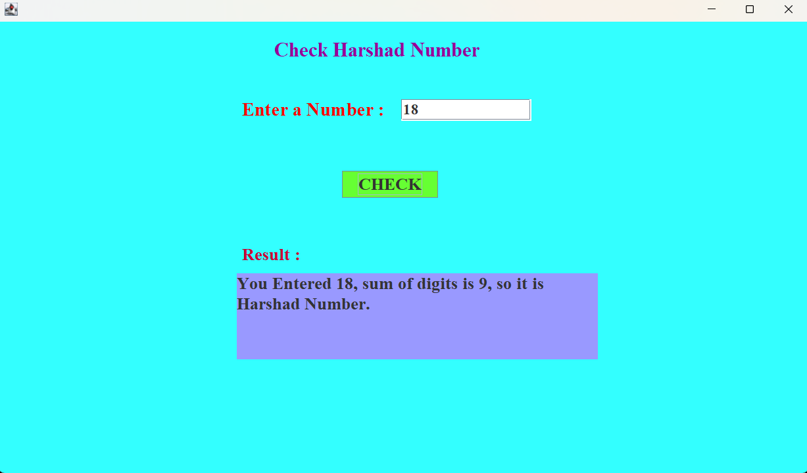
Output :-

SubTask 3 :- Automorphic Number
Code :-
import java.awt.EventQueue;

import javax.swing.JFrame;
import javax.swing.JPanel;
import javax.swing.border.EmptyBorder;
import java.awt.Color;
import javax.swing.JLabel;
import java.awt.Font;
import javax.swing.JTextField;
import javax.swing.JButton;
import javax.swing.JTextArea;
import java.awt.event.ActionListener;
import java.awt.event.ActionEvent;
public class AutomorphicNumber extends JFrame {
private static final long serialVersionUID = 1L;
private JPanel contentPane;
private JTextField data;
private JTextArea result;
/**
* Launch the application.
*/
public static void main(String[] args) {
EventQueue.invokeLater(new Runnable() {
public void run() {
try {
AutomorphicNumber frame = new AutomorphicNumber();
frame.setVisible(true);
} catch (Exception e) {
e.printStackTrace();
}
}
});
}
/**
* Create the frame.
*/
public AutomorphicNumber() {
setDefaultCloseOperation(JFrame.EXIT_ON_CLOSE);
setBounds(100, 100, 1003, 591);
contentPane = new JPanel();
contentPane.setBackground(new Color(102, 204, 204));
contentPane.setBorder(new EmptyBorder(5, 5, 5, 5));
setContentPane(contentPane);
contentPane.setLayout(null);
JLabel lblNewLabel = new JLabel("Check Automorphic Numbers");
lblNewLabel.setForeground(new Color(51, 0, 102));
lblNewLabel.setFont(new Font("Times New Roman", Font.BOLD, 25));
lblNewLabel.setBounds(312, 23, 324, 30);
contentPane.add(lblNewLabel);

JLabel lblNewLabel_1 = new JLabel("Enter a Number :");
lblNewLabel_1.setForeground(new Color(153, 51, 0));
lblNewLabel_1.setFont(new Font("Times New Roman", Font.BOLD, 23));
lblNewLabel_1.setBounds(296, 92, 184, 30);
contentPane.add(lblNewLabel_1);

data = new JTextField();
data.setFont(new Font("Times New Roman", Font.BOLD, 23));
data.setBounds(490, 95, 158, 26);
contentPane.add(data);
data.setColumns(10);

JButton btnNewButton = new JButton("CHECK");
btnNewButton.addActionListener(new ActionListener() {
public void actionPerformed(ActionEvent e) {
String input = data.getText().trim();
int number = Integer.parseInt(input);
long square = (long) number * number;

String strNumber = Integer.toString(number);
String strSquare = Long.toString(square);
String message;
if (strSquare.endsWith(strNumber)) {
message = "You Entered " + number + " and its square is " + square + ", so it is Automorphic Number.";
} else {
message = "You Entered " + number + " and its square is " + square + ", so it is not an Automorphic Number.";
}
result.setText(message);
}
});
btnNewButton.setBackground(new Color(153, 102, 153));
btnNewButton.setFont(new Font("Times New Roman", Font.BOLD, 21));
btnNewButton.setBounds(418, 182, 117, 33);
contentPane.add(btnNewButton);

JLabel lblNewLabel_2 = new JLabel("Result :");
lblNewLabel_2.setForeground(new Color(255, 0, 102));
lblNewLabel_2.setFont(new Font("Times New Roman", Font.BOLD, 21));
lblNewLabel_2.setBounds(296, 271, 76, 26);
contentPane.add(lblNewLabel_2);

result = new JTextArea();
result.setBackground(new Color(204, 255, 255));
result.setFont(new Font("Times New Roman", Font.BOLD, 23));
result.setBounds(296, 307, 374, 108);
result.setLineWrap(true);
result.setWrapStyleWord(true);
contentPane.add(result);
}
}
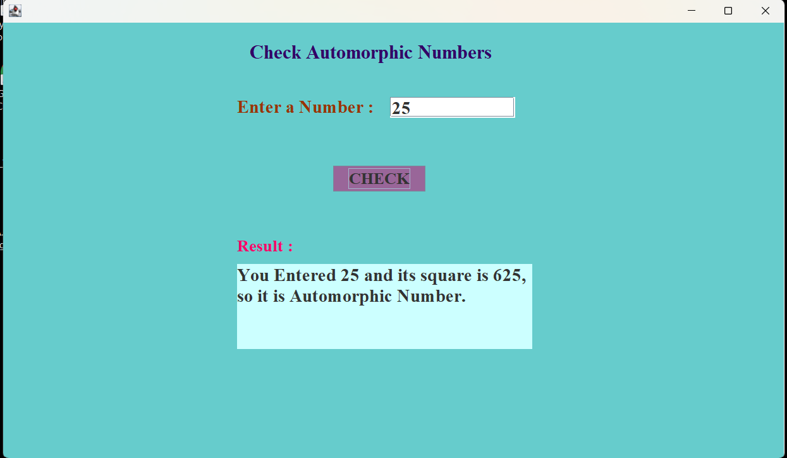
Output :-

SubTask 4 :- Amicable Number
Code :-
import java.awt.EventQueue;

import javax.swing.JFrame;
import javax.swing.JPanel;
import javax.swing.border.EmptyBorder;
import java.awt.Color;
import javax.swing.JLabel;
import java.awt.Font;
import javax.swing.JTextField;
import javax.swing.JButton;
import javax.swing.JTextArea;
import java.awt.event.ActionListener;
import java.awt.event.ActionEvent;

public class AmicableNumber extends JFrame {
private static final long serialVersionUID = 1L;
private JPanel contentPane;
private JTextField data;
private JTextField data2;
private JTextArea result;
/**
* Launch the application.
*/
public static void main(String[] args) {
EventQueue.invokeLater(new Runnable() {
public void run() {
try {
AmicableNumber frame = new AmicableNumber();
frame.setVisible(true);
} catch (Exception e) {
e.printStackTrace();
}
}
});
}
/**
* Create the frame.
*/
public AmicableNumber() {
setDefaultCloseOperation(JFrame.EXIT_ON_CLOSE);
setBounds(100, 100, 1001, 595);
contentPane = new JPanel();
contentPane.setBackground(new Color(216, 191, 216));
contentPane.setBorder(new EmptyBorder(5, 5, 5, 5));
setContentPane(contentPane);
contentPane.setLayout(null);

JLabel lblNewLabel = new JLabel("Check Amicable Number ");
lblNewLabel.setForeground(new Color(123, 104, 238));
lblNewLabel.setFont(new Font("Times New Roman", Font.BOLD, 25));
lblNewLabel.setBounds(335, 20, 298, 30);
contentPane.add(lblNewLabel);

JLabel lblNewLabel_1 = new JLabel("Enter 1st Number :");
lblNewLabel_1.setForeground(new Color(47, 79, 79));
lblNewLabel_1.setFont(new Font("Times New Roman", Font.BOLD, 23));
lblNewLabel_1.setBounds(282, 92, 209, 30);
contentPane.add(lblNewLabel_1);

data = new JTextField();
data.setFont(new Font("Times New Roman", Font.BOLD, 23));
data.setBounds(487, 94, 158, 26);
contentPane.add(data);
data.setColumns(10);

JLabel lblNewLabel_2 = new JLabel("Enter 2nd Number:");
lblNewLabel_2.setForeground(new Color(47, 79, 79));
lblNewLabel_2.setFont(new Font("Times New Roman", Font.BOLD, 23));
lblNewLabel_2.setBounds(282, 149, 202, 30);
contentPane.add(lblNewLabel_2);

data2 = new JTextField();
data2.setFont(new Font("Times New Roman", Font.BOLD, 23));
data2.setBounds(487, 151, 158, 26);
contentPane.add(data2);
data2.setColumns(10);

JButton btnNewButton = new JButton("CHECK");
btnNewButton.addActionListener(new ActionListener() {
public void actionPerformed(ActionEvent e) {
String input1 = data.getText().trim();
String input2 = data2.getText().trim();
int num1 = Integer.parseInt(input1);
int num2 = Integer.parseInt(input2);
int sum1 = 0, sum2 = 0;
for (int i=1; i<num1; i++) {
if (num1 % i == 0) sum1 += i;
}
for (int i=1; i<num2; i++) {
if (num2 % i == 0) sum2 += i;
}
String message;
if (sum1 == num2 && sum2 == num1) {
message = ("You entered " + num1 + " and " + num2 + ", result is Amicable Numbers.");
} else {
message = ("You entered " + num1 + " and " + num2 + ", result is not Amicable Numbers.");
}
result.setText(message);
}
});
btnNewButton.setBackground(new Color(124, 252, 0));
btnNewButton.setFont(new Font("Times New Roman", Font.BOLD, 21));
btnNewButton.setBounds(418, 225, 117, 33);
contentPane.add(btnNewButton);

JLabel lblNewLabel_3 = new JLabel("Result :");
lblNewLabel_3.setForeground(new Color(139, 0, 0));
lblNewLabel_3.setFont(new Font("Times New Roman", Font.BOLD, 21));
lblNewLabel_3.setBounds(296, 271, 76, 26);
contentPane.add(lblNewLabel_3);

result = new JTextArea();
result.setFont(new Font("Times New Roman", Font.BOLD, 23));
result.setLineWrap(true);
result.setWrapStyleWord(true);
result.setBounds(296, 307, 374, 108);
result.setBackground(new Color(204, 255, 255));
result.setLineWrap(true);
result.setWrapStyleWord(true);
contentPane.add(result);
}
}
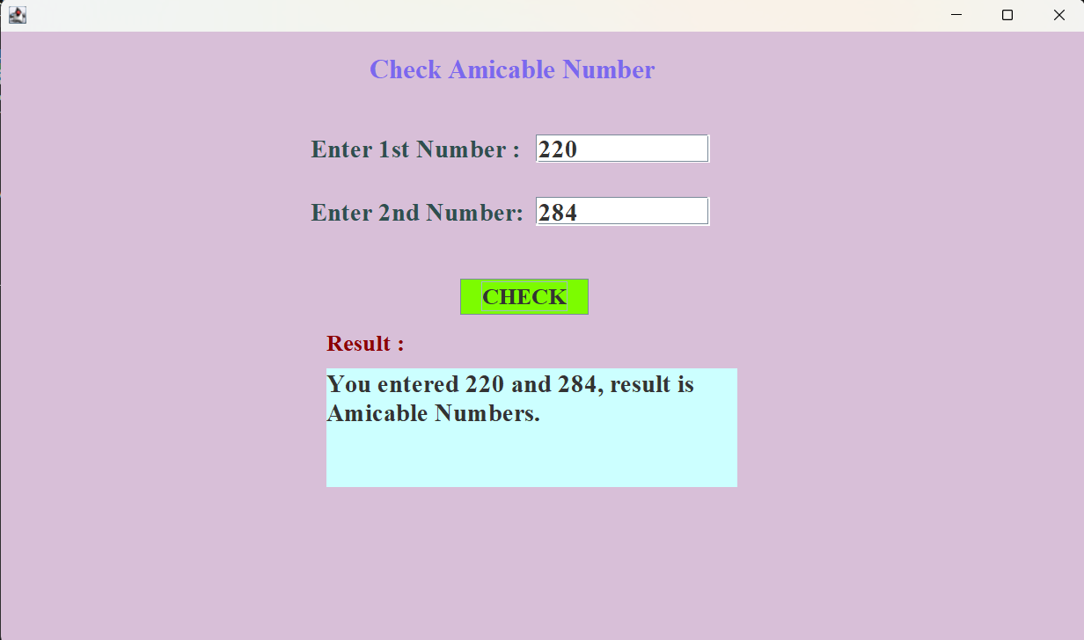
Output :-

SubTask 5:- Friendly Pair / Friendly Number
Code :-
import java.awt.EventQueue;

import javax.swing.JFrame;
import javax.swing.JPanel;
import javax.swing.border.EmptyBorder;
import java.awt.Color;
import javax.swing.JLabel;
import java.awt.Font;
import javax.swing.JTextField;
import javax.swing.JButton;
import javax.swing.JTextArea;
import java.awt.event.ActionListener;
import java.awt.event.ActionEvent;

public class FriendlyPairandFriendlyNumber extends JFrame {

private static final long serialVersionUID = 1L;
private JPanel contentPane;
private JTextField data;
private JTextField data2;
private JTextArea result;
/**
* Launch the application.
*/
public static void main(String[] args) {
EventQueue.invokeLater(new Runnable() {
public void run() {
try {
FriendlyPairandFriendlyNumber frame = new FriendlyPairandFriendlyNumber();
frame.setVisible(true);
} catch (Exception e) {
e.printStackTrace();
}
}
});
}

/**
* Create the frame.
*/
public FriendlyPairandFriendlyNumber() {
setDefaultCloseOperation(JFrame.EXIT_ON_CLOSE);
setBounds(100, 100, 1004, 599);
contentPane = new JPanel();
contentPane.setBackground(new Color(250, 235, 215));
contentPane.setBorder(new EmptyBorder(5, 5, 5, 5));
setContentPane(contentPane);
contentPane.setLayout(null);

JLabel lblNewLabel = new JLabel("Check Friendly Pair / Friendly Number");
lblNewLabel.setForeground(new Color(0, 139, 139));
lblNewLabel.setFont(new Font("Times New Roman", Font.BOLD, 25));
lblNewLabel.setBounds(278, 20, 427, 30);
contentPane.add(lblNewLabel);

JLabel lblNewLabel_1 = new JLabel("Enter 1st Number :");
lblNewLabel_1.setForeground(new Color(30, 144, 255));
lblNewLabel_1.setFont(new Font("Times New Roman", Font.BOLD, 23));
lblNewLabel_1.setBounds(296, 92, 204, 30);
contentPane.add(lblNewLabel_1);

JLabel lblNewLabel_1_1 = new JLabel("Enter 2nd Number :");
lblNewLabel_1_1.setForeground(new Color(30, 144, 255));
lblNewLabel_1_1.setFont(new Font("Times New Roman", Font.BOLD, 23));
lblNewLabel_1_1.setBounds(296, 151, 204, 30);
contentPane.add(lblNewLabel_1_1);

data = new JTextField();
data.setFont(new Font("Times New Roman", Font.BOLD, 23));
data.setBounds(500, 95, 158, 26);
contentPane.add(data);
data.setColumns(10);

data2 = new JTextField();
data2.setFont(new Font("Times New Roman", Font.BOLD, 23));
data2.setColumns(10);
data2.setBounds(500, 155, 158, 26);
contentPane.add(data2);

JButton btnNewButton = new JButton("CHECK");
btnNewButton.addActionListener(new ActionListener() {
public void actionPerformed(ActionEvent e) {
int num1 = Integer.parseInt(data.getText());
int num2 = Integer.parseInt(data2.getText());
int sum1 = sumDivisors(num1);
int sum2 = sumDivisors(num2);
double ratio1 = (double) sum1 / num1;
double ratio2 = (double) sum2 / num2;
if (ratio1 == ratio2) {
result.setText(num1 + " and " + num2 + " are Friendly Pair numbers.");
} else {
result.setText(num1 + " and " + num2 + " are not Friendly Pair numbers.");
}
}
private int sumDivisors(int n) {
int sum = 0;
for (int i=1; i<n; i++) {
if ( n % i == 0) sum = sum + i;
}
return sum;
}
});
btnNewButton.setBackground(new Color(95, 158, 160));
btnNewButton.setFont(new Font("Times New Roman", Font.BOLD, 18));
btnNewButton.setBounds(418, 240, 117, 33);
contentPane.add(btnNewButton);

JLabel lblNewLabel_2 = new JLabel("Result :");
lblNewLabel_2.setForeground(new Color(240, 128, 128));
lblNewLabel_2.setFont(new Font("Times New Roman", Font.BOLD, 21));
lblNewLabel_2.setBounds(296, 300, 76, 26);
contentPane.add(lblNewLabel_2);

result = new JTextArea();
result.setFont(new Font("Times New Roman", Font.BOLD, 23));
result.setBounds(296, 333, 397, 108);
contentPane.add(result);
}
}
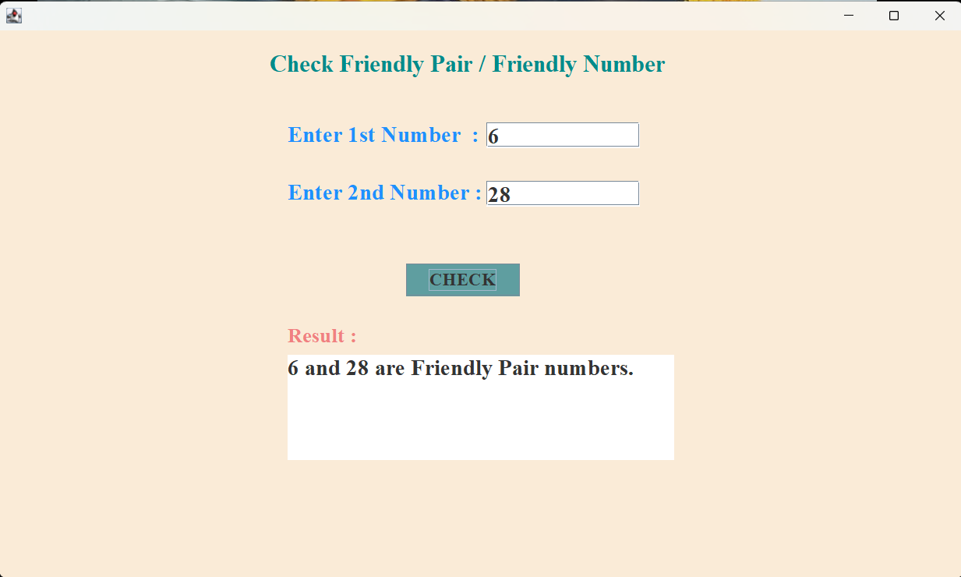
Output :-

SubTask 6 :- Twin Primes
Code :-
import java.awt.EventQueue;

import javax.swing.JFrame;
import javax.swing.JPanel;
import javax.swing.border.EmptyBorder;
import java.awt.Color;
import javax.swing.JLabel;
import java.awt.Font;
import javax.swing.JTextField;
import javax.swing.JButton;
import javax.swing.JTextArea;
import java.awt.event.ActionListener;
import java.awt.event.ActionEvent;

public class TwinPrimes extends JFrame {

private static final long serialVersionUID = 1L;
private JPanel contentPane;
private JTextField data;
private JTextField data2;
private JTextArea result;

/**
* Launch the application.
*/
public static void main(String[] args) {
EventQueue.invokeLater(new Runnable() {
public void run() {
try {
TwinPrimes frame = new TwinPrimes();
frame.setVisible(true);
} catch (Exception e) {
e.printStackTrace();
}
}
});
}
/**
* Create the frame.
*/
public TwinPrimes() {
setDefaultCloseOperation(JFrame.EXIT_ON_CLOSE);
setBounds(100, 100, 1015, 609);
contentPane = new JPanel();
contentPane.setBackground(new Color(153, 255, 153));
contentPane.setBorder(new EmptyBorder(5, 5, 5, 5));
setContentPane(contentPane);
contentPane.setLayout(null);

JLabel lblNewLabel = new JLabel("Twin Primes");
lblNewLabel.setForeground(new Color(204, 0, 255));
lblNewLabel.setFont(new Font("Times New Roman", Font.BOLD, 25));
lblNewLabel.setBounds(406, 23, 168, 30);
contentPane.add(lblNewLabel);

JLabel lblNewLabel_1 = new JLabel("Enter 1st Number :");
lblNewLabel_1.setForeground(new Color(153, 0, 255));
lblNewLabel_1.setFont(new Font("Times New Roman", Font.BOLD, 23));
lblNewLabel_1.setBounds(296, 92, 205, 30);
contentPane.add(lblNewLabel_1);

JLabel lblNewLabel_1_1 = new JLabel("Enter 2nd Number :");
lblNewLabel_1_1.setForeground(new Color(153, 0, 255));
lblNewLabel_1_1.setFont(new Font("Times New Roman", Font.BOLD, 23));
lblNewLabel_1_1.setBounds(296, 148, 205, 30);
contentPane.add(lblNewLabel_1_1);

data = new JTextField();
data.setFont(new Font("Times New Roman", Font.BOLD, 23));
data.setBounds(500, 95, 158, 26);
contentPane.add(data);
data.setColumns(10);

data2 = new JTextField();
data2.setFont(new Font("Times New Roman", Font.BOLD, 23));
data2.setColumns(10);
data2.setBounds(500, 148, 158, 26);
contentPane.add(data2);

JButton btnNewButton = new JButton("CHECK");
btnNewButton.addActionListener(new ActionListener() {
public void actionPerformed(ActionEvent e) {
int num1 = Integer.parseInt(data.getText());
int num2 = Integer.parseInt(data2.getText());
boolean isNum1Prime = isPrime(num1);
boolean isNum2Prime = isPrime(num2);
int difference = Math.abs(num1 - num2);

if (isNum1Prime&& isNum2Prime && difference == 2) {
result.setText(num1 + " and " + num2 + " are Twin Primes.");
} else {
result.setText(num1 + " and " + num2 + " are not Twin Primes.");
}
}
private boolean isPrime(int n) {
if (n <= 1) return false;
for (int i=2; i<=Math.sqrt(n); i++) {
if (n % i == 0) return false;
}
return true;
}
});
btnNewButton.setFont(new Font("Times New Roman", Font.BOLD, 18));
btnNewButton.setBackground(new Color(0, 255, 255));
btnNewButton.setBounds(430, 230, 117, 33);
contentPane.add(btnNewButton);

JLabel lblNewLabel_2 = new JLabel("Result :");
lblNewLabel_2.setForeground(new Color(255, 0, 255));
lblNewLabel_2.setFont(new Font("Times New Roman", Font.BOLD, 21));
lblNewLabel_2.setBounds(296, 290, 76, 26);
contentPane.add(lblNewLabel_2);

result = new JTextArea();
result.setFont(new Font("Times New Roman", Font.BOLD, 23));
result.setBounds(296, 315, 374, 105);
contentPane.add(result);

}

}
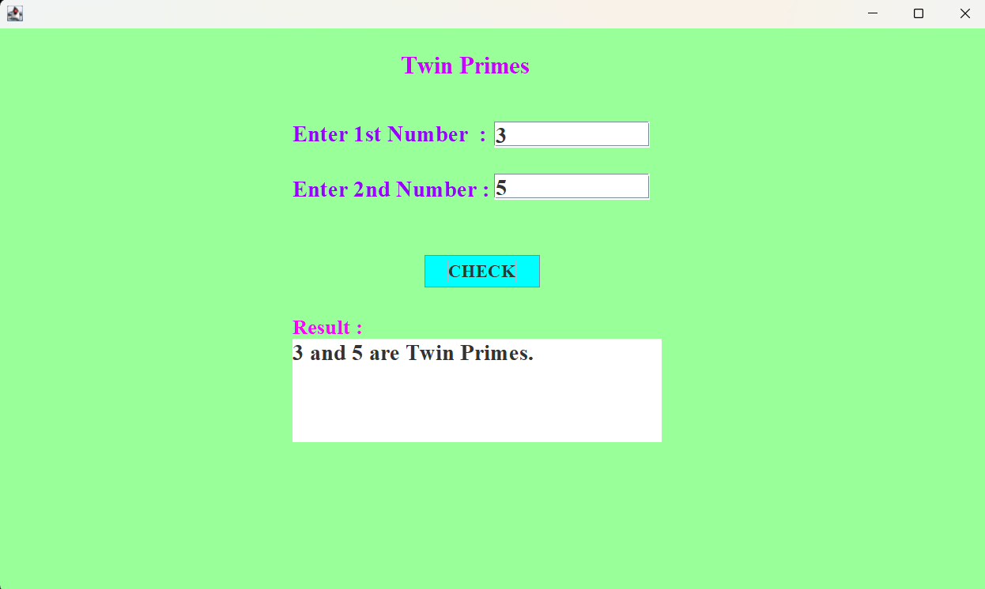
Output :-

SubTask 7:- Cousin Primes
Code :-
import java.awt.EventQueue;

import javax.swing.JFrame;
import javax.swing.JPanel;
import javax.swing.border.EmptyBorder;
import java.awt.Color;
import javax.swing.JLabel;
import java.awt.Font;
import javax.swing.JTextField;
import javax.swing.JButton;
import javax.swing.JTextArea;
import java.awt.event.ActionListener;
import java.awt.event.ActionEvent;

public class CousinPrimes extends JFrame {
private static final long serialVersionUID = 1L;
private JPanel contentPane;
private JTextField data;
private JTextField data2;
private JTextArea result;

/**
* Launch the application.
*/
public static void main(String[] args) {
EventQueue.invokeLater(new Runnable() {
public void run() {
try {
CousinPrimes frame = new CousinPrimes();
frame.setVisible(true);
} catch (Exception e) {
e.printStackTrace();
}
}
});
}

/**
* Create the frame.
*/
public CousinPrimes() {
setDefaultCloseOperation(JFrame.EXIT_ON_CLOSE);
setBounds(100, 100, 1023, 605);
contentPane = new JPanel();
contentPane.setBackground(new Color(255, 204, 153));
contentPane.setBorder(new EmptyBorder(5, 5, 5, 5));
setContentPane(contentPane);
contentPane.setLayout(null);

JLabel lblCousinPrimes = new JLabel(" Cousin Primes");
lblCousinPrimes.setForeground(new Color(102, 0, 255));
lblCousinPrimes.setFont(new Font("Times New Roman", Font.BOLD, 25));
lblCousinPrimes.setBounds(363, 20, 298, 30);
contentPane.add(lblCousinPrimes);

JLabel lblNewLabel_1 = new JLabel("Enter 1st Number :");
lblNewLabel_1.setForeground(new Color(0, 51, 102));
lblNewLabel_1.setFont(new Font("Times New Roman", Font.BOLD, 23));
lblNewLabel_1.setBounds(257, 93, 205, 30);
contentPane.add(lblNewLabel_1);

JLabel lblNewLabel_1_1 = new JLabel("Enter 2nd Number :");
lblNewLabel_1_1.setForeground(new Color(0, 51, 102));
lblNewLabel_1_1.setFont(new Font("Times New Roman", Font.BOLD, 23));
lblNewLabel_1_1.setBounds(257, 156, 220, 30);
contentPane.add(lblNewLabel_1_1);

data = new JTextField();
data.setFont(new Font("Times New Roman", Font.BOLD, 23));
data.setColumns(10);
data.setBounds(490, 95, 158, 26);
contentPane.add(data);

data2 = new JTextField();
data2.setFont(new Font("Times New Roman", Font.BOLD, 23));
data2.setColumns(10);
data2.setBounds(490, 156, 158, 26);
contentPane.add(data2);

JButton btnNewButton = new JButton("CHECK");
btnNewButton.addActionListener(new ActionListener() {
public void actionPerformed(ActionEvent e) {
int num1 = Integer.parseInt(data.getText());
int num2 = Integer.parseInt(data2.getText());
boolean isNum1Prime = isPrime(num1);
boolean isNum2Prime = isPrime(num2);
int difference = Math.abs(num1 - num2);

if (isNum1Prime&& isNum2Prime && difference == 4) {
result.setText(num1 + " and " + num2 + " are Cousin Primes.");
} else {
result.setText(num1 + " and " + num2 + " are not Cousin Primes.");
}
}
private boolean isPrime(int n) {
if (n <= 1) return false;
for (int i=2; i<=Math.sqrt(n); i++) {
if (n % i == 0) return false;
}
return true;
}
});
btnNewButton.setForeground(new Color(255, 255, 255));
btnNewButton.setFont(new Font("Times New Roman", Font.BOLD, 18));
btnNewButton.setBackground(new Color(51, 0, 51));
btnNewButton.setBounds(418, 249, 117, 33);
contentPane.add(btnNewButton);

JLabel lblNewLabel_2 = new JLabel("Result :");
lblNewLabel_2.setForeground(new Color(0, 128, 128));
lblNewLabel_2.setFont(new Font("Times New Roman", Font.BOLD, 21));
lblNewLabel_2.setBounds(257, 304, 76, 26);
contentPane.add(lblNewLabel_2);

result = new JTextArea();
result.setFont(new Font("Times New Roman", Font.BOLD, 23));
result.setBounds(257, 340, 391, 105);
contentPane.add(result);
}
}
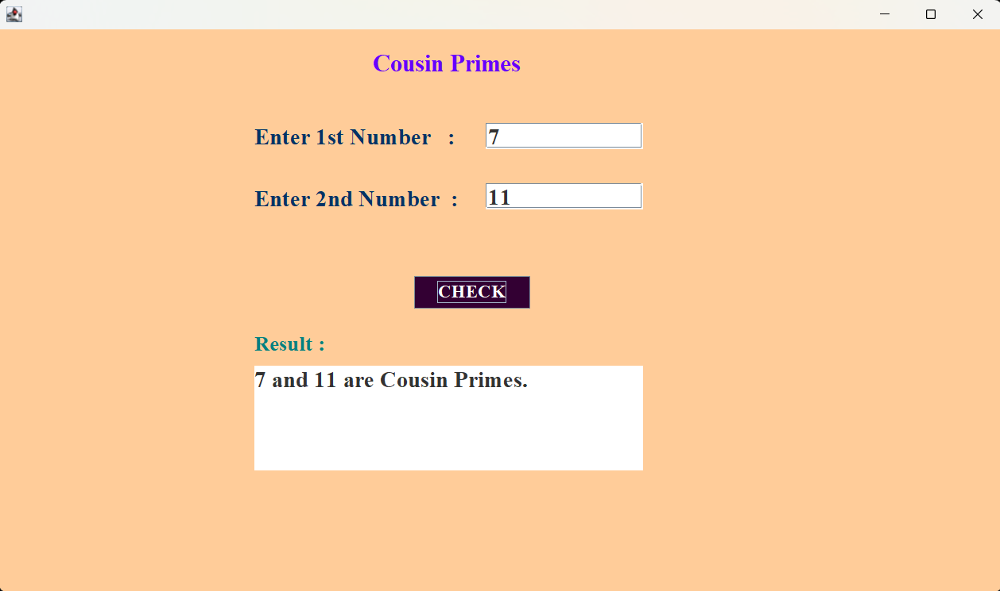
Output:-

SubTask 8:- Sexy Primes
Code :-
import java.awt.EventQueue;

import javax.swing.JFrame;
import javax.swing.JPanel;
import javax.swing.border.EmptyBorder;
import java.awt.Color;
import javax.swing.JLabel;
import java.awt.Font;
import javax.swing.JTextField;
import javax.swing.JButton;
import javax.swing.JTextArea;
import java.awt.event.ActionListener;
import java.awt.event.ActionEvent;

public class SexyPrimes extends JFrame {

private static final long serialVersionUID = 1L;
private JPanel contentPane;
private JTextField data;
private JTextField data2;
private JTextArea result;

/**
* Launch the application.
*/
public static void main(String[] args) {
EventQueue.invokeLater(new Runnable() {
public void run() {
try {
SexyPrimes frame = new SexyPrimes();
frame.setVisible(true);
} catch (Exception e) {
e.printStackTrace();
}
}
});
}

/**
* Create the frame.
*/
public SexyPrimes() {
setDefaultCloseOperation(JFrame.EXIT_ON_CLOSE);
setBounds(100, 100, 1032, 585);
contentPane = new JPanel();
contentPane.setBackground(new Color(224, 255, 255));
contentPane.setBorder(new EmptyBorder(5, 5, 5, 5));
setContentPane(contentPane);
contentPane.setLayout(null);

JLabel lblSexyPrimes = new JLabel(" Sexy Primes");
lblSexyPrimes.setForeground(new Color(255, 20, 147));
lblSexyPrimes.setFont(new Font("Times New Roman", Font.BOLD, 25));
lblSexyPrimes.setBounds(400, 20, 298, 30);
contentPane.add(lblSexyPrimes);

JLabel lblNewLabel_1 = new JLabel("Enter 1st Number :");
lblNewLabel_1.setForeground(new Color(160, 82, 45));
lblNewLabel_1.setFont(new Font("Times New Roman", Font.BOLD, 23));
lblNewLabel_1.setBounds(296, 92, 208, 30);
contentPane.add(lblNewLabel_1);

JLabel lblNewLabel_1_1 = new JLabel("Enter 2nd Number :");
lblNewLabel_1_1.setForeground(new Color(160, 82, 45));
lblNewLabel_1_1.setFont(new Font("Times New Roman", Font.BOLD, 23));
lblNewLabel_1_1.setBounds(296, 157, 218, 30);
contentPane.add(lblNewLabel_1_1);

data = new JTextField();
data.setFont(new Font("Times New Roman", Font.BOLD, 23));
data.setColumns(10);
data.setBounds(514, 94, 158, 26);
contentPane.add(data);

data2 = new JTextField();
data2.setFont(new Font("Times New Roman", Font.BOLD, 23));
data2.setColumns(10);
data2.setBounds(514, 157, 158, 26);
contentPane.add(data2);

JButton btnNewButton = new JButton("CHECK");
btnNewButton.addActionListener(new ActionListener() {
public void actionPerformed(ActionEvent e) {
int num1 = Integer.parseInt(data.getText());
int num2 = Integer.parseInt(data2.getText());
boolean isNum1Prime = isPrime(num1);
boolean isNum2Prime = isPrime(num2);
int difference = Math.abs(num1 - num2);

if (isNum1Prime&& isNum2Prime && difference == 6) {
result.setText(num1 + " and " + num2 + " are Cousin Primes.");
} else {
result.setText(num1 + " and " + num2 + " are not Cousin Primes.");
}
}
private boolean isPrime(int n) {
if (n <= 1) return false;
for (int i=2; i<=Math.sqrt(n); i++) {
if (n % i == 0) return false;
}
return true;
}
});
btnNewButton.setForeground(Color.WHITE);
btnNewButton.setFont(new Font("Times New Roman", Font.BOLD, 18));
btnNewButton.setBackground(new Color(65, 105, 225));
btnNewButton.setBounds(425, 253, 117, 33);
contentPane.add(btnNewButton);

JLabel lblNewLabel_2 = new JLabel("Result :");
lblNewLabel_2.setForeground(new Color(255, 99, 71));
lblNewLabel_2.setFont(new Font("Times New Roman", Font.BOLD, 21));
lblNewLabel_2.setBounds(296, 323, 76, 26);
contentPane.add(lblNewLabel_2);

result = new JTextArea();
result.setBackground(new Color(255, 228, 225));
result.setForeground(new Color(0, 0, 0));
result.setFont(new Font("Times New Roman", Font.BOLD, 23));
result.setBounds(291, 359, 391, 105);
contentPane.add(result);

}

}

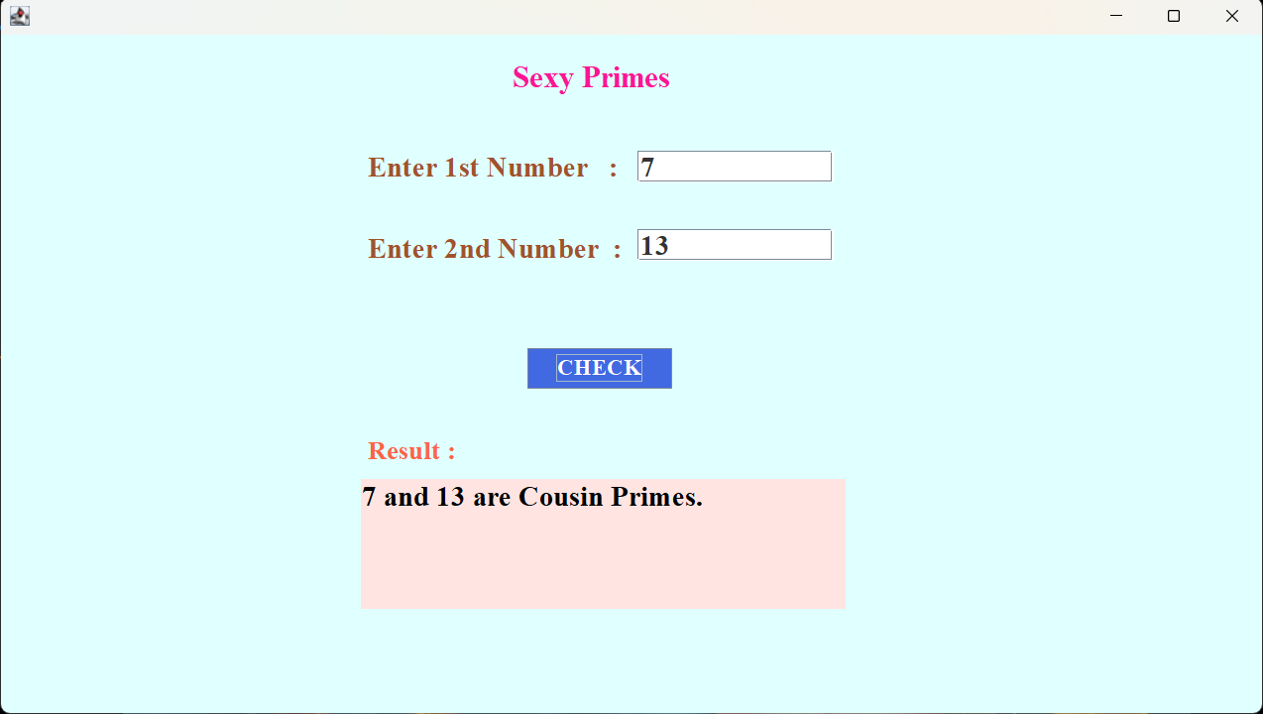
Output:-

SubTask 9:- Perfect Number
Code :
import java.awt.EventQueue;

import javax.swing.JFrame;
import javax.swing.JPanel;
import javax.swing.border.EmptyBorder;
import java.awt.Color;
import javax.swing.JLabel;
import java.awt.Font;
import javax.swing.JTextField;
import javax.swing.JButton;
import javax.swing.JTextArea;
import java.awt.event.ActionListener;
import java.awt.event.ActionEvent;

public class PerfectNumber extends JFrame {

private static final long serialVersionUID = 1L;
private JPanel contentPane;
private JTextField data;
private JTextArea result;
/**
* Launch the application.
*/
public static void main(String[] args) {
EventQueue.invokeLater(new Runnable() {
public void run() {
try {
PerfectNumber frame = new PerfectNumber();
frame.setVisible(true);
} catch (Exception e) {
e.printStackTrace();
}
}
});
}

/**
* Create the frame.
*/
public PerfectNumber() {
setDefaultCloseOperation(JFrame.EXIT_ON_CLOSE);
setBounds(100, 100, 1027, 595);
contentPane = new JPanel();
contentPane.setBackground(new Color(255, 192, 203));
contentPane.setBorder(new EmptyBorder(5, 5, 5, 5));
setContentPane(contentPane);
contentPane.setLayout(null);

JLabel lblSexyPrimes = new JLabel("Check Perfect Number");
lblSexyPrimes.setForeground(new Color(128, 0, 0));
lblSexyPrimes.setFont(new Font("Times New Roman", Font.BOLD, 25));
lblSexyPrimes.setBounds(390, 22, 298, 30);
contentPane.add(lblSexyPrimes);

JLabel lblNewLabel_1 = new JLabel("Enter Number :");
lblNewLabel_1.setForeground(new Color(72, 61, 139));
lblNewLabel_1.setFont(new Font("Times New Roman", Font.BOLD, 23));
lblNewLabel_1.setBounds(330, 97, 208, 30);
contentPane.add(lblNewLabel_1);

data = new JTextField();
data.setFont(new Font("Times New Roman", Font.BOLD, 23));
data.setColumns(10);
data.setBounds(530, 99, 158, 26);
contentPane.add(data);

JButton btnNewButton = new JButton("CHECK");
btnNewButton.addActionListener(new ActionListener() {
public void actionPerformed(ActionEvent e) {
int number = Integer.parseInt(data.getText());
int sum = 0;
for (int i=1; i<number; i++) {
if (number % i == 0) {
sum = sum + i;
}
}
if (sum == number && number != 0) {
result.setText(number + " is a Perfect Number.");
} else {
result.setText(number + " is not a Perfect Number.");
}
}
});
btnNewButton.setForeground(Color.WHITE);
btnNewButton.setFont(new Font("Times New Roman", Font.BOLD, 18));
btnNewButton.setBackground(new Color(65, 105, 225));
btnNewButton.setBounds(459, 212, 117, 33);
contentPane.add(btnNewButton);

JLabel lblNewLabel_2 = new JLabel("Result :");
lblNewLabel_2.setForeground(new Color(255, 0, 0));
lblNewLabel_2.setFont(new Font("Times New Roman", Font.BOLD, 21));
lblNewLabel_2.setBounds(324, 303, 76, 26);
contentPane.add(lblNewLabel_2);

result = new JTextArea();
result.setForeground(Color.BLACK);
result.setFont(new Font("Times New Roman", Font.BOLD, 23));
result.setBackground(new Color(135, 206, 235));
result.setBounds(319, 336, 391, 105);
contentPane.add(result);

}
}

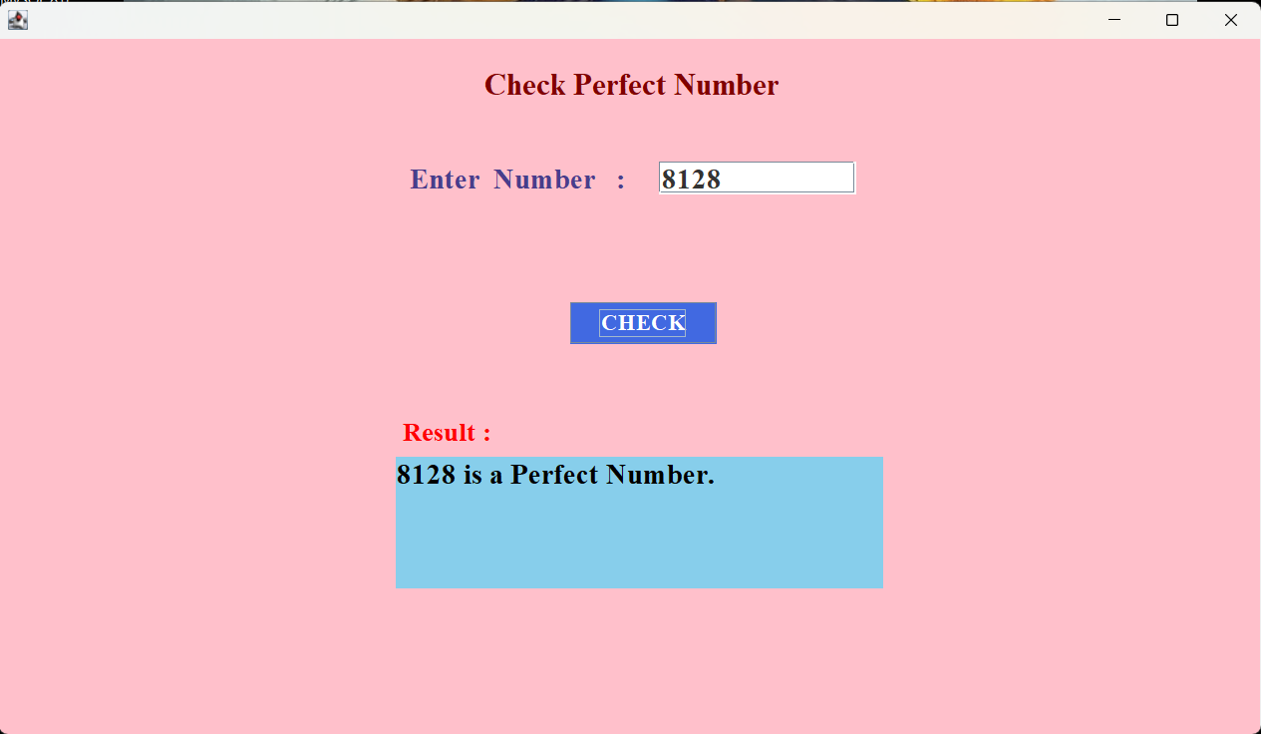
Output :-

SubTask 10:- Deficit Number
Code
import java.awt.EventQueue;

import javax.swing.JFrame;
import javax.swing.JPanel;
import javax.swing.border.EmptyBorder;
import java.awt.Color;
import javax.swing.JLabel;
import java.awt.Font;
import javax.swing.JTextField;
import javax.swing.JButton;
import javax.swing.JTextArea;
import java.awt.event.ActionListener;
import java.awt.event.ActionEvent;

public class DeficitNumber extends JFrame {

private static final long serialVersionUID = 1L;
private JPanel contentPane;
private JTextField data;
private JTextArea result;

/**
* Launch the application.
*/
public static void main(String[] args) {
EventQueue.invokeLater(new Runnable() {
public void run() {
try {
DeficitNumber frame = new DeficitNumber();
frame.setVisible(true);
} catch (Exception e) {
e.printStackTrace();
}
}
});
}

/**
* Create the frame.
*/
public DeficitNumber() {
setDefaultCloseOperation(JFrame.EXIT_ON_CLOSE);
setBounds(100, 100, 1025, 630);
contentPane = new JPanel();
contentPane.setBackground(new Color(64, 224, 208));
contentPane.setBorder(new EmptyBorder(5, 5, 5, 5));
setContentPane(contentPane);
contentPane.setLayout(null);

JLabel lblCheckPdeficitnumber = new JLabel("Check Deficit Number");
lblCheckPdeficitnumber.setForeground(new Color(75, 0, 130));
lblCheckPdeficitnumber.setFont(new Font("Times New Roman", Font.BOLD, 25));
lblCheckPdeficitnumber.setBounds(370, 25, 298, 30);
contentPane.add(lblCheckPdeficitnumber);

JLabel lblNewLabel_1 = new JLabel("Enter Number :");
lblNewLabel_1.setForeground(new Color(0, 0, 0));
lblNewLabel_1.setFont(new Font("Times New Roman", Font.BOLD, 23));
lblNewLabel_1.setBounds(322, 96, 182, 30);
contentPane.add(lblNewLabel_1);

data = new JTextField();
data.setFont(new Font("Times New Roman", Font.BOLD, 23));
data.setColumns(10);
data.setBounds(510, 98, 158, 26);
contentPane.add(data);

JButton btnNewButton = new JButton("CHECK");
btnNewButton.addActionListener(new ActionListener() {
public void actionPerformed(ActionEvent e) {
int number = Integer.parseInt(data.getText());
int sum = 0;
for (int i=1; i<number; i++) {
if (number % i == 0) {
sum = sum + i;
}
}
if (sum < number) {
result.setText(number + " is a Deficit or Deficient Number.");
} else {
result.setText(number + " is not a Deficit or Deficient Number.");
}
}
});
btnNewButton.setForeground(Color.WHITE);
btnNewButton.setFont(new Font("Times New Roman", Font.BOLD, 18));
btnNewButton.setBackground(new Color(255, 165, 0));
btnNewButton.setBounds(429, 189, 117, 33);
contentPane.add(btnNewButton);

JLabel lblNewLabel_2 = new JLabel("Result :");
lblNewLabel_2.setForeground(new Color(255, 69, 0));
lblNewLabel_2.setFont(new Font("Times New Roman", Font.BOLD, 21));
lblNewLabel_2.setBounds(322, 280, 76, 26);
contentPane.add(lblNewLabel_2);

result = new JTextArea();
result.setForeground(Color.BLACK);
result.setFont(new Font("Times New Roman", Font.BOLD, 23));
result.setBackground(new Color(60, 179, 113));
result.setBounds(317, 320, 391, 105);
contentPane.add(result);

}

}

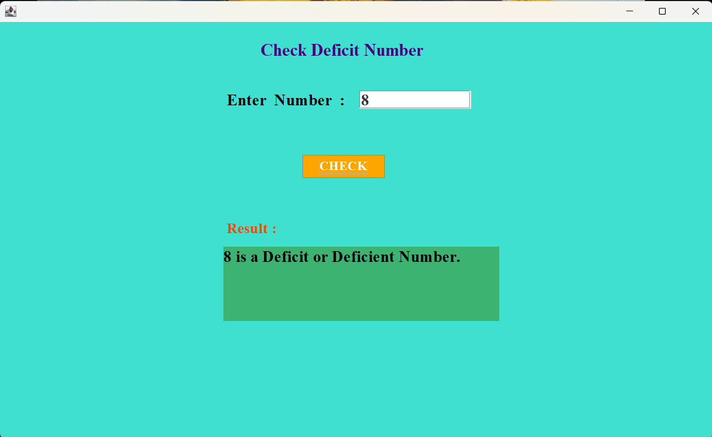
Output :-

SubTask 11:- Square - Free Number
Code
import java.awt.EventQueue;

import javax.swing.JFrame;
import javax.swing.JPanel;
import javax.swing.border.EmptyBorder;
import java.awt.Color;
import javax.swing.JLabel;
import java.awt.Font;
import javax.swing.JTextField;
import javax.swing.JButton;
import javax.swing.JTextArea;
import java.awt.event.ActionListener;
import java.awt.event.ActionEvent;

public class SquareFree extends JFrame {

private static final long serialVersionUID = 1L;
private JPanel contentPane;
private JTextField data;
private JTextArea result;

/**
* Launch the application.
*/
public static void main(String[] args) {
EventQueue.invokeLater(new Runnable() {
public void run() {
try {
SquareFree frame = new SquareFree();
frame.setVisible(true);
} catch (Exception e) {
e.printStackTrace();
}
}
});
}

/**
* Create the frame.
*/
public SquareFree() {
setDefaultCloseOperation(JFrame.EXIT_ON_CLOSE);
setBounds(100, 100, 1031, 586);
contentPane = new JPanel();
contentPane.setBackground(new Color(255, 228, 181));
contentPane.setBorder(new EmptyBorder(5, 5, 5, 5));
setContentPane(contentPane);
contentPane.setLayout(null);

JLabel lblSquareFreeNumber = new JLabel("Square Free Number");
lblSquareFreeNumber.setForeground(new Color(0, 0, 128));
lblSquareFreeNumber.setFont(new Font("Times New Roman", Font.BOLD, 25));
lblSquareFreeNumber.setBounds(395, 10, 237, 30);
contentPane.add(lblSquareFreeNumber);

JLabel lblNewLabel_1 = new JLabel("Enter Number :");
lblNewLabel_1.setForeground(Color.MAGENTA);
lblNewLabel_1.setFont(new Font("Times New Roman", Font.BOLD, 23));
lblNewLabel_1.setBounds(349, 107, 182, 30);
contentPane.add(lblNewLabel_1);

data = new JTextField();
data.setFont(new Font("Times New Roman", Font.BOLD, 23));
data.setColumns(10);
data.setBounds(528, 109, 158, 26);
contentPane.add(data);

JButton btnNewButton = new JButton("CHECK");
btnNewButton.addActionListener(new ActionListener() {
public void actionPerformed(ActionEvent e) {
int number = Integer.parseInt(data.getText());
if (isSquareFree(number)) {
result.setText(number + " is a Square-Free number.");
} else {
result.setText(number + " is not a Square-Free number.");
}
}
private boolean isSquareFree(int n) {
for (int i=2; i * i <= n; i++) {
if (n % (i * i) == 0) {
return false;
}
}
return true;
}
});
btnNewButton.setForeground(Color.WHITE);
btnNewButton.setFont(new Font("Times New Roman", Font.BOLD, 18));
btnNewButton.setBackground(Color.GREEN);
btnNewButton.setBounds(450, 211, 117, 33);
contentPane.add(btnNewButton);

JLabel lblNewLabel_2 = new JLabel("Result :");
lblNewLabel_2.setForeground(Color.DARK_GRAY);
lblNewLabel_2.setFont(new Font("Times New Roman", Font.BOLD, 21));
lblNewLabel_2.setBounds(349, 293, 76, 26);
contentPane.add(lblNewLabel_2);

result = new JTextArea();
result.setForeground(Color.BLACK);
result.setFont(new Font("Times New Roman", Font.BOLD, 23));
result.setBackground(new Color(255, 228, 225));
result.setBounds(349, 329, 391, 105);
contentPane.add(result);

}
}Output :- 